What is the Great Pacific garbage patch? Smith, Naazir

I will be going into a deep explanation of what the great pacific garbage patch is. How it received its name. what has caused it to become a such an issue. Lastly what part can we play to prevent the issue from expanding. Due to its size spanning twice the size of Texas. The floating garbage is affecting the hydrosphere. I will be doing the research on what it affects it has hydrosphere over time.

The Great pacific garbage patch was something I was not familiar with but caught my eye at first glance. The Great Pacific garbage patch (GPGP) for short also Is known as the pacific trash vortex. From a brief glance from oceanservice.noaa.gov. The GPGP is a gyre of marine debris particles in the north-central Pacific Ocean. In short trash, debris, dead animals of such are swept away though the currents and become pulled in this centralized location. I chose this topic due to my recent fascination with environmental preservation. After the last assignment I read about how the aquifer works and how it could easily become polluted with our negligence. I have wanted to venture more down the path of pollution. When reading the suggestions on what topics could be covered in the final. The GPGP stood out, primally due to me never hearing about it before.

The information sources will be heavily based from online editorials, creditable researchers, and other sites including national geographic, Britannica, oceanservice, Forbes and YouTube. I be searching for Flowcharts and sequence diagrams to display the increase of waste in the GPGP over time. Charts will display what type of waste materials were recovered from the GPGP over time. Lastly visual graphics to show what the GPGP looks like now compared to 20 years ago.

How will all this research provide results. I will be researching the information from the sources stated above. The focus will be to answer 3 major questions. 1. What has cased this issue. 2. How is this affecting our Hydrosphere. And 3. What preventive measures can we take to resolve or prevent worsening conditions of our oceans. This topic will be examined and expressed in a research. The paper format using illustrations to convey supporting points. Charts with supplemental data will also be added to display time laps of the GPGP worsening over the years. I would like to then use that data to create my own chart to display what our current status of the ocean waste system looks like. Then showing what its projected to be in 10 years without treatment.

This is some information I have gathered so far.

Nature.com
There is new evidence that the GPGP is accumulating plastic. In the sub-tropical waters near California and Hawaii new studies are showing that thousands of tons of ocean plastic are floating inside of the GPGP.
Nature.com explains that over ¾ of the GPGP mas was debris larger the 5cm in which most of the debris consist of fishing nets. When only 8% of it was microplastics. (this is interesting due to the common focus on the subject of proper waste management and how our plastic is ending up in the ocean.) (note. We should be turning our focus on fishing awareness.)
Nature.com- Around 60% of the plastic produced is less dense than seawater. When introduced into the marine environment, buoyant plastic can be transported by surface currents and winds, recaptured by coastlines, degraded into smaller pieces by the action of sun, temperature variations, waves and marine life, or lose buoyancy and sink. A portion of these buoyant plastics, however, is transported offshore and enters oceanic gyres.
Nature.com-From July 27th to September 19th, 2015, a total of 652 surface net tows were carried out between 25°N–41°N and 129–156°W by 18 participating vessels. In October 2016, we revisited our study area by conducting two flights with a Hercules C-130 aircraft that collected aerial imagery (n = 7,298 single-frame mosaics) to better quantify the larger and rarer >50 cm plastic objects (Fig. 1).
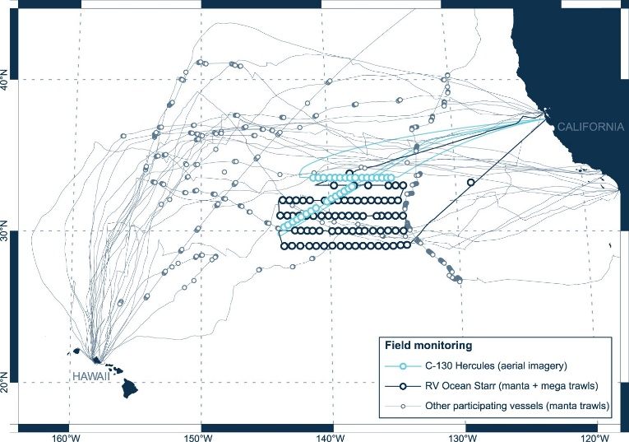
Field monitoring effort. Vessel (grey and dark blue lines) and aircraft (light blue lines) tracks and locations where data on buoyant ocean plastic concentrations were collected (circles). Grey circles (n = 350) represent areas sampled with a single Manta net tow by 17 participating vessels, between July and September 2015. Dark blue circles (n = 76) represent areas sampled with paired Manta and paired Mega net tows by RV Ocean Starr, between July and August 2015. Light blue circles (n = 31) show locations of RGB geo-referenced mosaics collected from a C-130 Hercules aircraft, in October 2016.
LeBreton, Laurent, et al. "Evidence that the Great Pacific Garbage Patch is rapidly accumulating plastic." Scientific reports 8.1 (2018): 1-15.

Video Links I will be referencing

https://www.youtube.com/watch?v=0EyaTqezSzs
https://www.youtube.com/watch?v=6HBtl4sHTqU
https://www.nbcnews.com/video/large-garbage-patch-floating-in-the-pacific-ocean-318824003814

monitoring the hydrosphere by Bob Riddle PDF. I will be pulling information from here to show how the GPGP is affecting the Hydrosphere.
Riddle, Bob. "Monitoring the hydrosphere." Science Scope 42.5 (2019): 18.
As well as I will be referencing. Water Pollution by Microplastics and Microbeads very briefly due to the editorial being mostly in Russian.

Maximenko, Taisiya S., and Elena G. Ivanova. "Water Pollution by Microplastics and Microbeads." Recent Achievements and Prospects of Innovations and Technologies. 2018.

